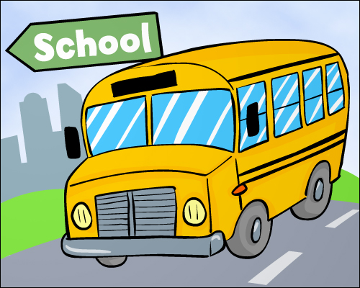

**Third Grade News**

**Mrs. Eiken’s Class**

**September 1, 2023**

**Here are our “I can” statements for next week.**

**ELA**:

*I can apply common spelling patterns to decode multisyllabic words in context and independent of context.

*I can draw conclusions and support the conclusions with textual evidence.

*I can summarize a story or text’s beginning, middle, and end and determine the central message, lesson, or moral.

*I can distinguish the literal and/or non-literal meanings of words and phrases in context.

*I can produce evidence of independent reading.

*I can summarize and sequence the events/plot.

*I can establish a setting*,* situation/topic*,*narrator and/or characters *(in fiction or nonfiction narratives and poems).*

*I can use the narrative technique of descriptions *(in fiction or nonfiction narratives and poems).*

**Math:**

*I can demonstrate fluency with addition and subtraction within 1000.

**Social Studies**: (unit 1)

*I can select and analyze sources to determine importance.

*I can create and use artifacts to share information.

*I can use visual tools and informational texts to interpret, draw conclusions, predict and communicate ideas.

*I can identify facts and opinions and point of view.

*I can present research to an audience.

*I can generate questions about a topic.

*I can use steps to investigate a question and share results.

**Science: (unit 1)**

*I can plan and conduct investigations to determine the cause and effect of relationships of electric or magnetic interactions.

|  |  |  |  |  |
| --- | --- | --- | --- | --- |
| **monday** | tuesday | wednesday | Thursda y | friday |
| **4**  **No School**  **Labor Day** | **5**  7:45  Character assembly | **6** | **7** | **8**  **Alibi Cookie fundraiser begins** |
| **11** | **12** | **13** | **14** | **15** |
| **18** | **19** | **20** | **21** | **22** |

**September**

If you have not yet signed up for Class Dojo, please do so. This is a great way to communicate and see what is happening in our classroom.

Conferences will be in November. If you want a head start signing up for a time, my link is <https://signup.com/go/EoVbSYW>

Please encourage your child to read 20 minutes every night. I would love to hear that you shared a book during our morning meeting!

Pizza orders are due September 15th. Thanks for supporting our PTO.

**Specials:**

**Monday – No school**

**Tuesday – Music**

**Wednesday – PE**

**Thursday – Art**

**Friday – Music**